**Faker API**

To solidify the concepts of making our own api, we are going to create an api that generates a random user on a GET request. We will be using Postman to make our GET requests.

In this assignment, we will be using 2 javascript libraries to create a simple API that generates a User and/or Company depending on the route:

Express (Server)

Faker (Fake data generator)

Go ahead and follow the checklist below using the 2 classes below:

User class

_id

firstName

lastName

phoneNumber

email

password

Company class

_id

name

address

street

city

state

zipCode

country

Faker

The faker library has a ton of methods we can use to populate specific fields with randomly generated data. Look through the faker [documentation](https://github.com/marak/Faker.js/) and search through the methods to choose the ones that you would use to populate each field.

**Here is an example of how we can use faker**

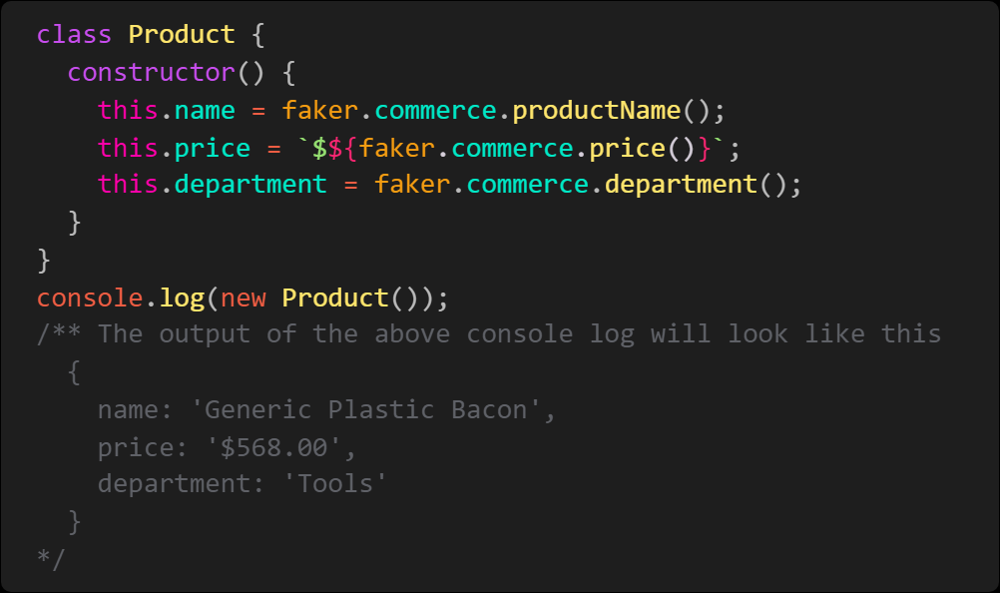

* Top of Form
* Create a new project folder "Faker_API" and with your terminal, navigate into your new folder
* Create a package.json file using the "npm init -y" command in your terminal
* install express and faker
* Create a server.js file
* In your server.js file, Import express and faker
* Create 2 classes: User, Company with the same attributes as listed above
* Create an api route "/api/users/new" that returns a new user
* Create an api route "/api/companies/new" that returns a new company
* Create an api route "/api/user/company" that returns both a new user and a new company
* Run your server.js file using nodemon
* Using Postman, test your new GET routes

Bottom of Form